**School of Information Management**

**INFO 5590 Information Management Systems**

**Fall 2020/2021**

Author: Razia Choudhury

**Lab7 - Information Systems in Organizations 4:**

**Business Intelligence and Analytics With Tableau**

1. **Inventory visualization**.

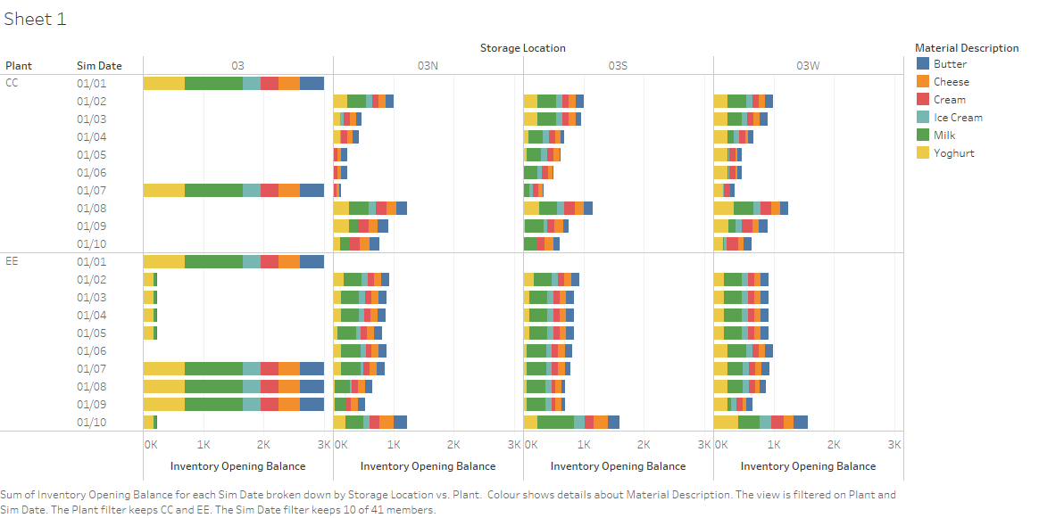

The plant CC belongs to my group which is compared with plant EE on the inventory balance of all the dairy products for the first 10 days of Round 1. As seen in the illustration, plant CC has pushed all the products to the respective storage locations the very next day of the main warehouse overload. Our push strategy was to sell all the products but we did not keep in mind the sale constraints like products running out of stock. As seen yougurt was highly in demand in the 03N and 03S regions and was running out of stock after the first three days of sale also Milk was following a similar trend in the 03W region, so Team CC could have changed the stock transfer strategy after the second replinshment to overcome these issues and highly profit from the sales. On the other hand, Team EE pushed all the products except Milk and Yogurt to the regional warehouses after the first main warehouse replenishment. This was a good strategy to observe the product demands in the respective locations. However, Team EE could have highly profited after the second overload if they would have changed the business process of stock transfers.

1. **Sales Visualization**

As seen below, all the companies are compared based on the total NET Value — value of the transaction (the QUANTITY_DELIVERED * NET_PRICE) of the product Milk in each of the four rounds. My company — Team CC — had the highest total net value of milk in the first round which depreciated in the second round followed by a significant rise in the third round. As observed, Team DD had the lowest milk net value in all the rounds except the last round where they experienced a high rise. On the other hand, Team II maintained a constant graph in all the rounds except the 3rd round. Team EE followed a linear increase in the net value of milk as the game progressed. This suggests that all these teams have made necessary changes in the milk prices and the inventory management strategies to keep up with the market trends.

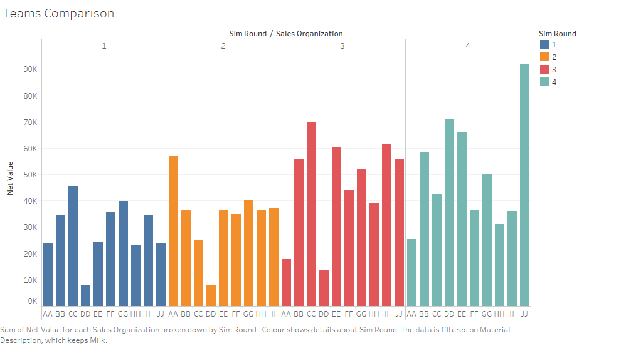

1. **Milk prices and profitabilty Analysis**

To analyze the milk transactions and relative profitability, I created the following illustration demonstrating the number of milk transactions that took place throughtout the game for each of the MILK NET_PRICE( the price set by the team) and the subsequent profit gained by four companies — CC,DD,EE and II.

* Team CC experimented with many price changes in round 2 thereby reducing the number of milk transactions and contribution margin. However, by the fourth round the team set a couple of stable prices to maximise profit.
* Team DD had set very high price of the milk product which reduced their NET_VALUE(as observed in the above graph), the number of transactions thereby reducing the profit margin. However, they made the necessary changes in the fourth round to wisely operate profitability.
* Team EE had a very good price set up for the product milk throughout the game which helped them to gain a linear increase in profits.
* Team II made maximum profits in the first two rounds by keeping a high price for milk. However, they expreimented by extremely reducing the price of milk which caued them heavy losses.

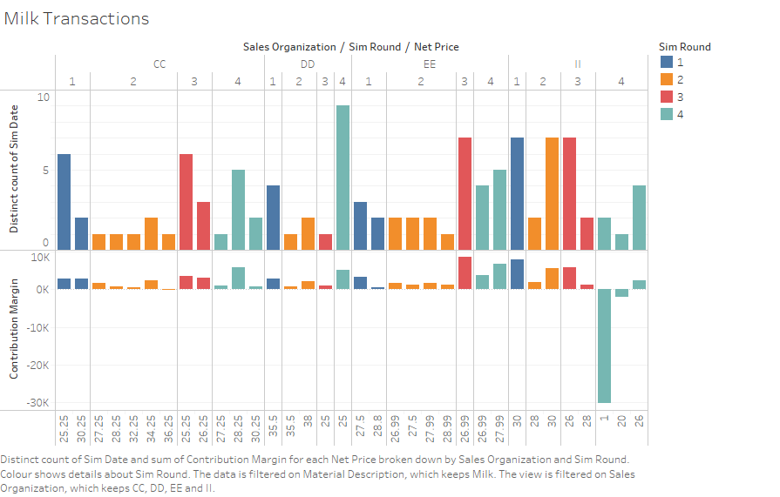

To analyze the working processes of the above mentioned teams , I created the below illustrations.

* Team CC’s star products were milk and yogurt which could have been managed in an optimised way.
* Team II did experiment with all the products prices in the 4th round which led to their downfall.
* Team EE constantly analyzed the product demands and working prices which helped them to make better decisions and achieve maximum profits.
* Team DD improved their business process strategies (product prices) in the final round which increased their company’s valuation.

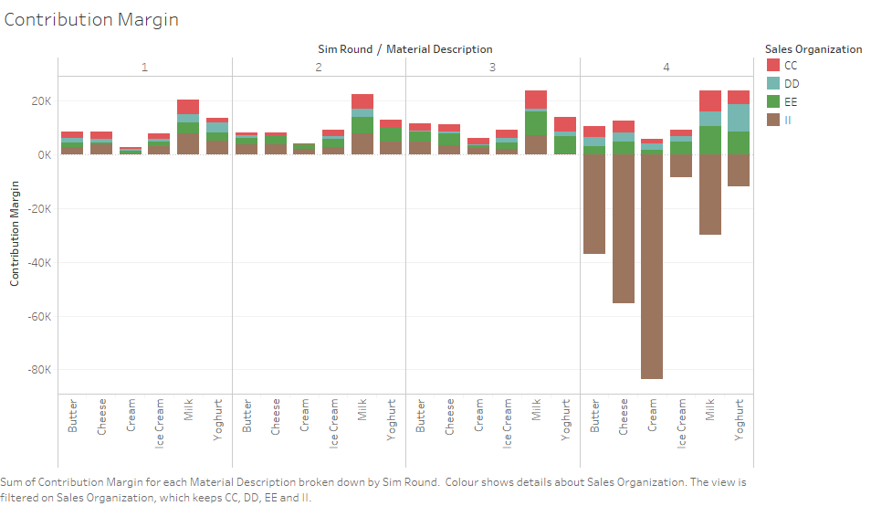

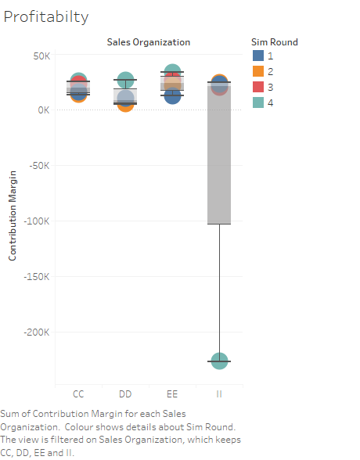

**KEY FINDINGS FOR TEAM CC TO OPERATE PROFITABILITY**

* The business process — Stock Transfers — could have been managed strategically to improve sales and curb losses. The team could have executed the pull strategy instead of doing a push always.
* The product prices should have been critically evaluated and changed. The team should have analytically identified the products which were high/low in demand and wisely increased/reduced the prices to achieve maximum profit.
* Effective Collaboration between the inventory and stock transfers managers would have encouraged change in the warehouse management techniques to overcome issues like running out of stock and no sale.
* Effective collaboration between the sales and prices managers would have helped to set the product prices accordingly and improved the company’s contribution margin.
* Analysing the previous rounds generated reports of different business processes and market trends would have helped in effective sale predictions and enabled data-driven decision making.
* Constantly supervising the working processes could provide the above mentioned valuable insights to achieve the business optimization goals.